**Saturday May 11th, 2019 Daily Coding Journal**

21:39 — Off to a late start today (had Vietnamese class plus other obligations). Let’s try to still get a solid hour or so of coding in.

21:40 — Let’s see if I can finally build the counting app from scratch.

21:49 — After some tinkering around I’ve got the basics all done. Check it out: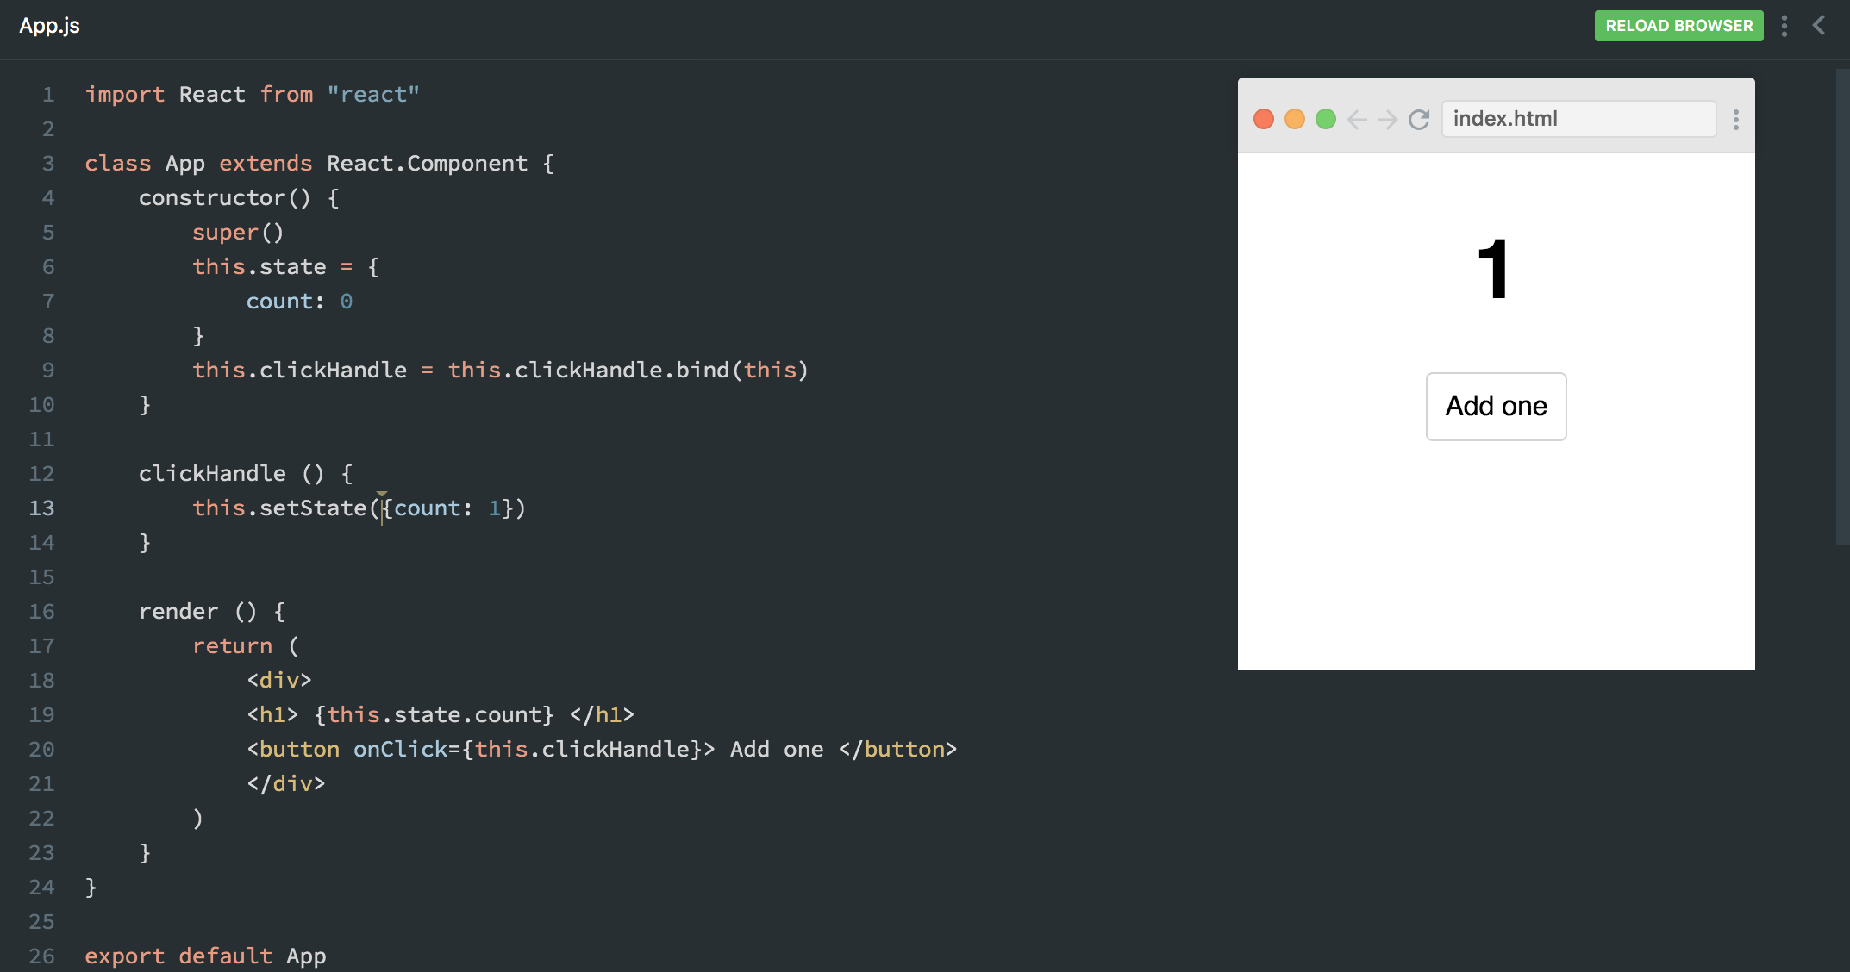

21:50 — Now I’ll make this more dynamic by passing a function into my setState method instead of simply passing an object. This will allow me to account for the previous state of my element rather than always setting my state to a single value irrespective of the previous state.

21:57 — I finally did it! It wasn’t easy, but I’ve finally created a working version of the above project without consulting anyone else’s code. I had several small errors along the way:

—Writing my arrow function syntax in the wrong order

— Forgetting return statements

— Forgetting the this keyword on at least one occasion

21:59 — With that being said, I still managed to get everything done. Check it out: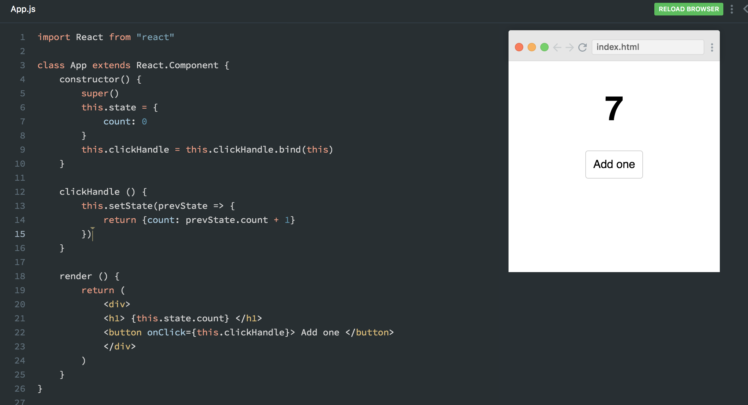

22:00 — How will we celebrate? By moving on to the next challenge. From what I saw a couple days ago, the next challenge looks like a beast O_O.

22:06 — I’ve listened to the instructions several times but I’m feeling just completely lost with how I should go about solving this challenge. I have to find someway of breaking this challenge down into smaller steps. I can’t just say I want the clicked items to go from checked to unchecked or vise versa.

22:07 — There needs to be logical thoughts that follow every step of the process.

22:14 — Thus far I’ve created an onChange event for something to happen when a toDo item changes from isCompleted: true to isCompleted: false and vice versa.

22:18 — I’ve made a little progress but I’m having difficulty figuring out exactly what my onChange method should do. I’m going to close my eyes and take a break for 5 minutes or so before going at this another 20 minutes and calling it a night.

22:24 — I still don’t know what to do, but at least my eyes feel less dry after that 5 minute break haha.

22:35 — I ended up watching what the instructor did to solve the problem. A lot of it went over my head. It’s going to take me a few hours to internalize all of the steps I think. While I understood some of the things he was explaining, I’m confident that getting a decent grasp of the presented material is going to take repeated exposures.

22:42 — I watched the video again, but to be honest… I didn’t take much out of it. I’m going to try to sleep on things and see if I can come back mentally stronger tomorrow.

**Total time spent coding today: 1 hour 1 minute**

**Total time spent coding thus far in May 2019: 21 hours 16 minutes**

**Total lifetime hours of coding: 517 hours 10 minutes**